How We Can Help You
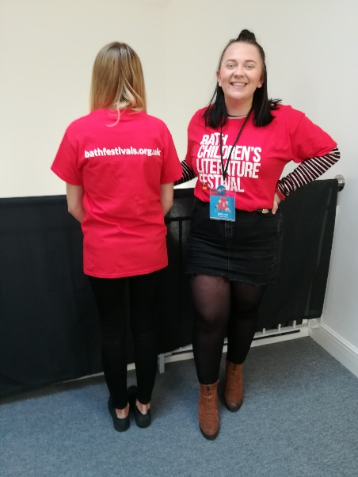
Our festival staff wear t-shirts or lanyards like this. You can ask festival staff for help if:
- You feel anxious
- You want to get into an event early
- You don’t like to queue
      - You want to sit next to the exit or somewhere quieter
During the event:
Sometimes authors go to events like festivals to talk about their book.
Usually the author stands at the front and reads some of their book or answers questions.
There may be lots of people asking questions so usually people take turns and the author asks people for their questions.
It can be busy and noisy but also interesting.
There might be lights or music, if someone doesn’t like sounds or music they could ask a volunteer if they can sit somewhere quieter, this is ok.
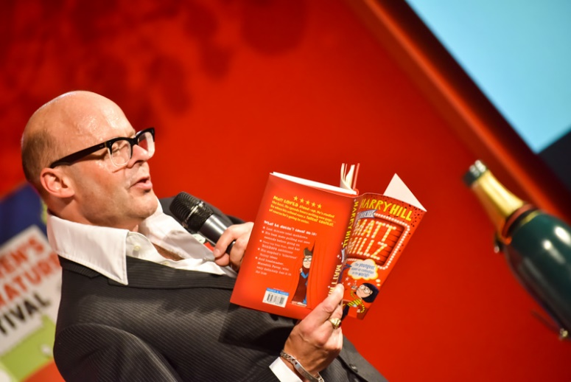
Meeting an author can be great fun.
After the event:
Sometimes authors come to events or festivals to meet the people who like their books. Sometimes this is called a book signing.
At a book signing people get in a queue and wait their turn to meet the author. Queueing can be boring, but we sometimes have to do it.
When it is your turn the author might say hello to you or ask a question, then they will sign your book.
Once your book is signed your turn is finished and it will be someone else’s turn.
Going to a book signing can be great fun, we are sure you will enjoy yourself.
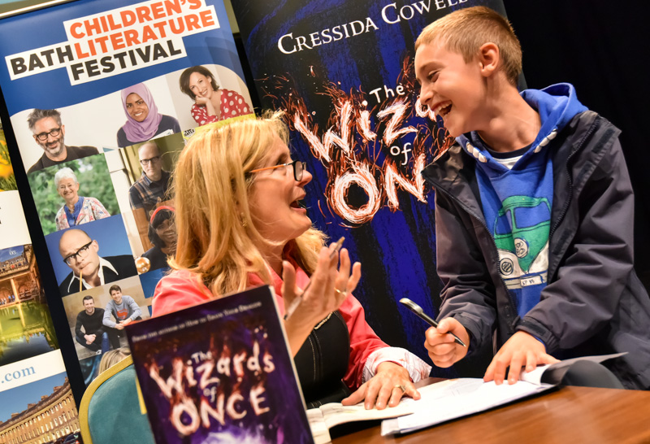

Thanks to Emma Cooper from The Mendip School who wrote these Social Scripts for Bath Children’s Literature Festival.

