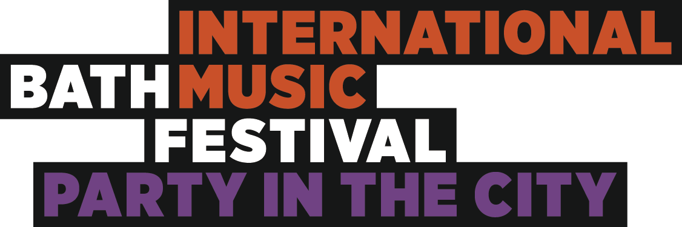
20th May 2016
Thank you for your interest in Party in the City 2016 – The opening of the Bath International Music Festival.
What is Party in the City?
The opening night of the Bath International Music Festival is Party in the City; a huge night of free music in concert venues, parks, churches, outdoor stages, restaurants and bars across the city, showcasing local and national talent as part of an internationally renowned Festival. Bath Festivals coordinates and promotes the evening which includes live music, street theatre, special commissions, education projects, community projects, dance, visual arts, performance art, spoken word and much more.
How can I take part?
If you are a musician or involved in any performing or visual art we would love to hear from you. The majority of the evening is dedicated to music but we love showcasing art, dance and anything cultural alongside during the festival. The first step in the process is to fill in the Party in the City application form and email it to pitc2016@bathfestivals.org.uk
What happens next?
If you are selected to perform, we will notify you of your venue and time slot via email. We will then put you in touch with your venue/event manager with whom you can arrange load-ins, tech-specs and all the final details.
Each venue on average hosts 6 acts on the evening, each performing a modest slot of about 30 minutes. Performers will be given their load in time and line-check times. Some live music venues have great sound systems, sound technicians, pianos, crew and riders – a lot do not. The more willing and able you are to be self-sufficient, the better your chances of your ideal slot and venue.
Who will be listening?
In 2015 over 20,000 people descended on 48 venues in and around Bath and we hope to increase this number year on year. Alongside Twitter, Facebook, E-news and all of our venues respective social media, we also produce 20,000 Party in the City brochures to promote you and the event. As well as your own fan-base, other acts will also be watching. After your act has finished playing, it’s tradition to head to one of our outdoor stages to support the other bands and have a drink!

Will I get paid?
Unfortunately not. Bath Festivals is a registered charity and programmes, produces and promotes the night for free to the general public. As it is free, unfortunately there is no ticket income to cover performer’s costs.
I have an idea for Party in the City…
If you want to arrange your own event for Party in the City please get in touch at pitc2016@bathfestivals.org.uk with your idea. We are happy to help execute your plans and we love innovative events!
What do I do now?
Complete the performance participation form and send it to pitc2016@bathfestivals.org.uk along with any further questions! Unfortunately we cannot accept any incomplete applications.
We look forward to hearing from you…

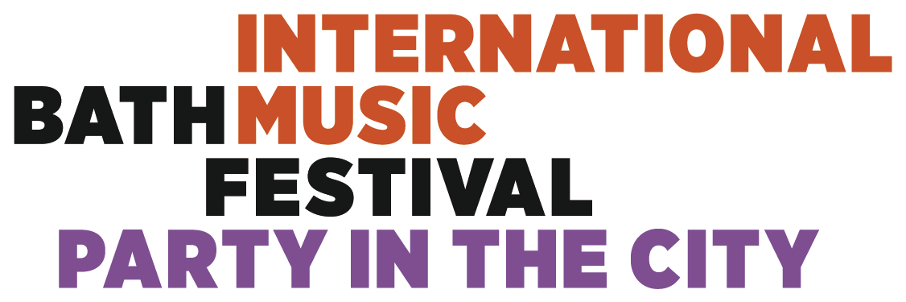
Name of Group/Act/Band/Performer
Contact Name
Contact Number

Email
Genre of Music / Performance
Number of Performers
Instruments Used
(We are unable to provide backline, if you require a piano please state this)
Your preferred venue(s)
(e.g. A church, A Bar, Parade Gardens)
Tell us a bit about your performance!
(50 words max)
If you had 30 words to entice an audience to your performance… write them here >>
(examples at bathfestivals.org.uk)
Please provide a link for us to see or hear you in action.
Any Other Comments?

Along with a high-res image of your act (minimum 2mb), please return your completed form to pitc2016@bathfestivals.org.uk no later than 31st December 2015.

